Analysis of the popular books dataset Focusing on the Harry Potter Series

**Name:** Hashem Ahmed Abdel-hafiz

**Id:** 20221445676

**Results:**

1. We started by comparing the ratings of all books on the same graph to highlight the difference in numbers

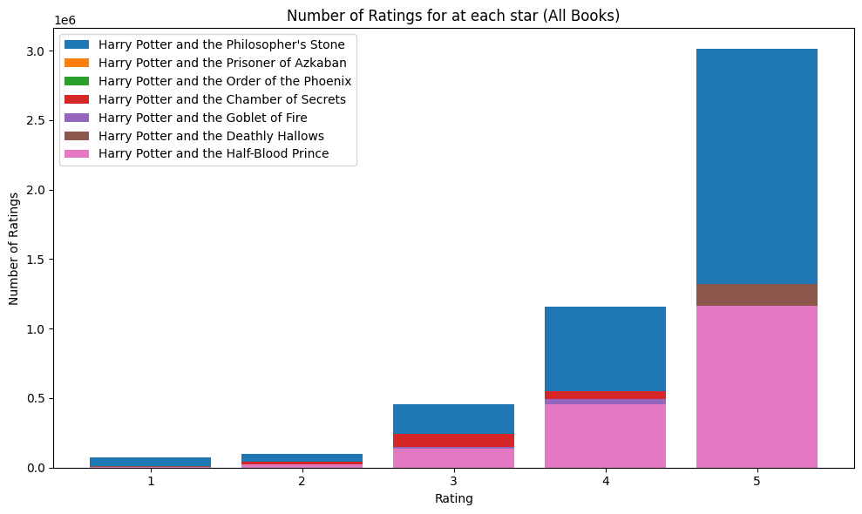

here we can see that **Harry potter and the philosopher’s stone** is the **highest rated book in all star rankings** with a big difference in between the 4 and 5 star ratings, however it is not the most liked book in the series

1. Diving deeper by plotting the total rankings we can see that **the most rated book and the best**

**selling** is **Harry potter and the philosopher’s stone**, this is primarly due the the reason it being the starting book in the series and the oldest

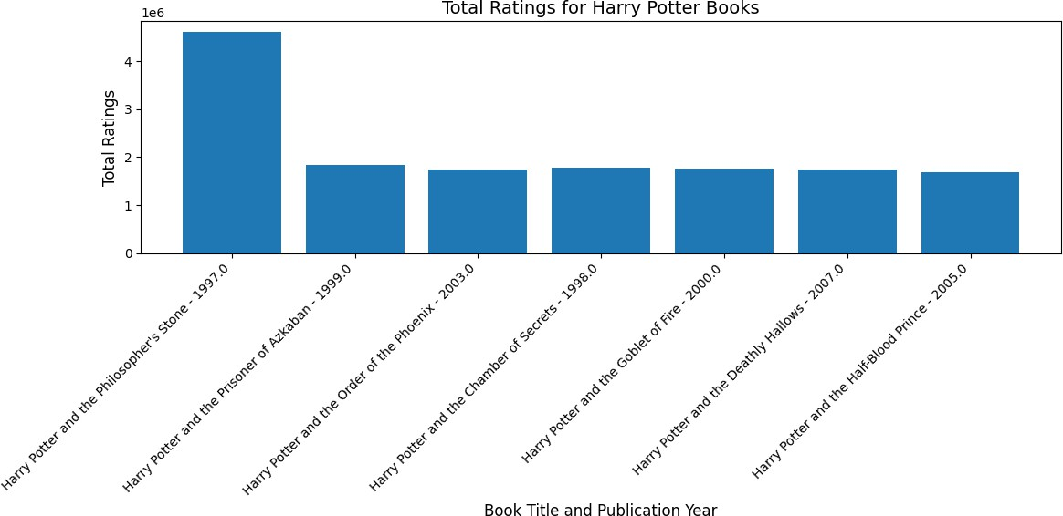

1. Next we wanted to find the most liked book in the series this was achieved by using the weighted average as the book ratings are not the same this is the formula that we used

∑(𝑨𝒗𝒆𝒓𝒂𝒈𝒆 𝒓𝒂𝒕𝒊𝒏𝒈 ∗ 𝑹𝒂𝒕𝒊𝒏𝒈𝒔 𝒄𝒐𝒖𝒏𝒕)

𝒘𝒆𝒊𝒈𝒉𝒕𝒆𝒅 𝒂𝒗𝒆𝒓𝒂𝒈𝒆 =

∑(𝑹𝒂𝒕𝒊𝒏𝒈𝒔 𝒄𝒐𝒖𝒏𝒕)

And we did so for all of the books this was the following result:

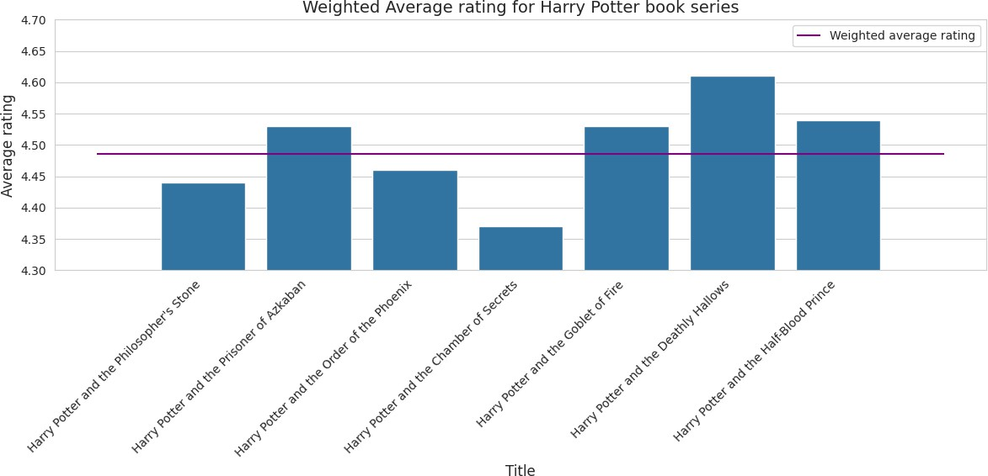

we can see here that **the weighted average** for the entire series is **4.48** with the **Harry potter and the deathly hollows having the highest average rating.**

1. Focusing on the most liked by seeing which has the most 5 star rating from the readers

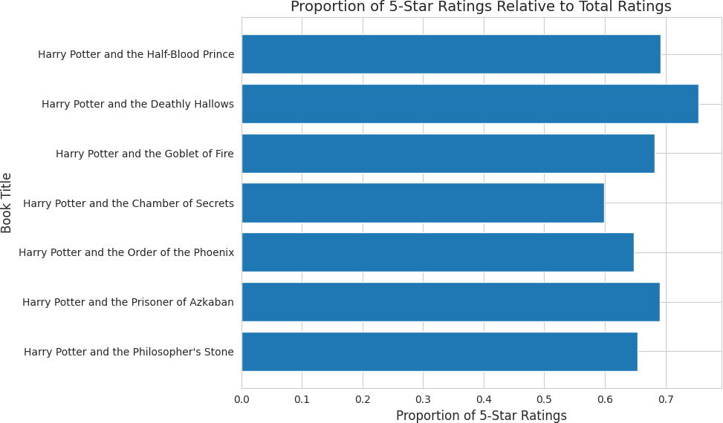

We can see that the **Harry Potter and the Deathly hollows has the most 5 star ratings** from the total ratings of the readers reaching **75% 5 star ratings.**

**Key findings:**

The **most read and bought book** in the series is the **Harry potter and the philosopher’s stone** while the **most liked with the highest average and with highest 5-star ratings** is **Harry Potter and the Deathly hollows**